**Explorations with First and Second Derivative of a Polynomial Function**

You can show your work in another document or on this page where there is room.

**I. Investigating extrema.**

A.

Use technology of your choosing to complete the following.

1) Graph y = x4 + x3 – x2 – 6x + 5.



Choose a window that will allow you to see all

maxima and minima. Paste a screen shot of your

graph along with identifying the window you chose

or sketch the graph on the right.

2) Locate all maxima and minima.

relative maxima: relative minima:

3) Find the equation of the derivative of the function in #1.



4) Graph the derivative in the same window

you graphed the function in #1. Paste a screen shot

of the graph or sketch the graph on the right.

|  |  |  |
| --- | --- | --- |
| **x** | **f(x)** | **f’(x)** |
|  |  |  |
|  |  |  |
|  |  |  |
|  |  |  |
|  |  |  |
|  |  |  |
|  |  |  |
|  |  |  |
|  |  |  |
|  |  |  |
|  |  |  |
|  |  |  |

5) Using the same technology or a different technology tool of your choosing, create a table of values containing x, the original function value, and the derivative value. The x-values should increase or decrease by 0.25. Paste a screen shot of your table.

6) What do you notice?

7) Find the second derivative of the function in #1.



8) Graph the second derivative you found

in #7 in the same window as the function and its

first derivative. Paste a screen shot of the graph

or sketch the graphs on the right.

|  |  |  |  |
| --- | --- | --- | --- |
| **x** | **f(x)** | **f’(x)** | **f”(x)** |
|  |  |  |  |
|  |  |  |  |
|  |  |  |  |
|  |  |  |  |
|  |  |  |  |
|  |  |  |  |
|  |  |  |  |
|  |  |  |  |
|  |  |  |  |
|  |  |  |  |
|  |  |  |  |
|  |  |  |  |

9) Using the same technology or a different

technology tool of your choosing, create a table

of values containing x, the original function value,

the first derivative value, and the second derivative

value. The x-values should increase or decrease by

0.25. Paste a screen shot of your table or write it to

the right. (If you are using a graphing calculator,

have the screen shot show x, the first derivative

value, and the second derivative value.)

10) What do you notice?

B.



Use technology of your choosing to complete the following.

1) Graph y = x4 + x3 + 3x2 – 8x – 6. Choose a

window that will allow you to see all maxima and minima.

Paste a screen shot of your graph along with identifying

the window you chose or sketch the graph on the right.

2) Locate all maxima and minima.

relative maxima: relative minima:

3) Find the equation of the derivative of the function in #1.

4) Graph the derivative in the same window



you graphed the function in #1. Paste a screen shot

of the graph or sketch the graph on the right.

|  |  |  |
| --- | --- | --- |
| **x** | **f(x)** | **f’(x)** |
|  |  |  |
|  |  |  |
|  |  |  |
|  |  |  |
|  |  |  |
|  |  |  |
|  |  |  |
|  |  |  |
|  |  |  |
|  |  |  |
|  |  |  |
|  |  |  |

5) Using the same technology or a different technology tool of your choosing, create a table of values containing x, the original function value, and the derivative value. The x-values should increase or decrease by 0.25. Paste a screen shot of your table.

6) What do you notice?

7) Find the second derivative of the function in #1.



8) Graph the second derivative you found in #7

in the same window as the function and its first derivative.

Paste a screen shot of the graph or sketch the graph on

the right.

|  |  |  |  |
| --- | --- | --- | --- |
| **x** | **f(x)** | **f’(x)** | **f”(x)** |
|  |  |  |  |
|  |  |  |  |
|  |  |  |  |
|  |  |  |  |
|  |  |  |  |
|  |  |  |  |
|  |  |  |  |
|  |  |  |  |
|  |  |  |  |
|  |  |  |  |
|  |  |  |  |
|  |  |  |  |

9) Using the same technology or a different technology tool of your choosing, create a table of values containing x, the original function value, the first derivative value, and the second derivative value. The x-values should increase or decrease by 0.25. Paste a screen shot of your table. (If you are using a graphing calculator, have the screen shot show x, the first derivative value, and the second derivative value.)

10) What do you notice?

C.

This time, before completing the questions, I want you to make predictions about some of the values as noted. Then confirm whether you are correct with the technology of your choosing.



1) Graph y = x4 – x3 – x2 + 15x + 4. Choose a

window that will allow you to see all maxima and

minima. Paste a screen shot of your graph along

with identifying the window you chose or sketch

the graph on the right.

2) Locate all maxima and minima.

relative maxima: relative minima:

3) Find the equation of the derivative of the function in #1.



4) Graph the derivative in the same window

you graphed the function in #1. Paste a screen shot

of the graph or sketch the graph on the right.

|  |  |  |
| --- | --- | --- |
| **x** | **f(x)** | **f’(x)** |
|  |  |  |
|  |  |  |
|  |  |  |
|  |  |  |
|  |  |  |
|  |  |  |
|  |  |  |
|  |  |  |
|  |  |  |
|  |  |  |
|  |  |  |
|  |  |  |

5) Using the same technology or a different technology tool of your choosing, create a table of values containing x, the original function value, and the derivative value. The x-values should increase or decrease by 0.25. Paste a screen shot of your table.

6) What do you notice?

Prediction:

Actual:

7) Find the second derivative of the function in #1.



8) Graph the second derivative you found in #7 in

the same window as the function and its first derivative.

Paste a screen shot of the graph. or sketch the graph on

the right

|  |  |  |  |
| --- | --- | --- | --- |
| **x** | **f(x)** | **f’(x)** | **f”(x)** |
|  |  |  |  |
|  |  |  |  |
|  |  |  |  |
|  |  |  |  |
|  |  |  |  |
|  |  |  |  |
|  |  |  |  |
|  |  |  |  |
|  |  |  |  |
|  |  |  |  |
|  |  |  |  |
|  |  |  |  |

9) Using the same technology or a different technology tool of your choosing, create a table of values containing x, the original function value, the first derivative value, and the second derivative value. The x-values should increase or decrease by 0.25. Paste a screen shot of your table. (If you are using a graphing calculator, have the screen shot show x, the first derivative value, and the second derivative value.)

10) What do you notice?

Prediction:

Actual:

D. Generalization

There are two tests for local extrema. Based on your explorations in parts A-C, state what you think the tests are.

1) First Derivative Test for Local Extrema

State in your own words how you can use the first derivative to determine where extrema are located and how to determine if it is a maximum or a minimum.

2) Second Derivative Test for Local Extrema

State in your own words how you can use the first derivate and the second derivative to determine where extrema are located and how to determine if it is a maximum or a minimum.

3) Think back to applications you have previously done in mathematics. Name some applications that you think it would be important to be able to identify the maximum or minimum of a function easily.

**II. Investigating Concavity**

We have previously talked about increasing and decreasing functions.

Recall:

If a function is increasing over an interval, the first derivative values in that interval are ______.

If a function is decreasing over an interval, the first derivative values in that interval are ______.

We can also look at how the graph turns. This is called *concavity*. If the curve of the graph turns upward, we say the graph is *concave up* for that interval. If the curve of the graph turns downward, we say the graph is *concave down* for that interval. The point where concavity changes is called *the point of inflection*.

A. Estimations

1) Look back at the graph you created for y = x4 + x3 – x2 – 6x + 5 in A. 1.



Paste a screen shot of the graph or sketch the graph

on the right. Use colored pencils to shade where you

think the graph is concave up (in one color) and concave

down (in a different color). Be sure to label which color

represents each.

a) For what interval(s) do you think the graph

is concave up?

b) For what interval(s) do you think the graph

is concave down?

c) Where do you think the inflection point(s) are?

2) Look back at the graph you created for y = x4 + x3 + 3x2 – 8x – 6 in B. 1.



Paste a screen shot of the graph or sketch the graph

on the right. Use colored pencils to shade where you

think the graph is concave up (in one color) and concave

down (in a different color). Be sure to label which color

represents each.

a) For what interval(s) do you think the graph is

concave up?

b) For what interval(s) do you think the graph is

concave down?

c) Where do you think the inflection point(s) are?

3) Look back at the graph you created for y = x4 – x3 – x2 + 15x + 4 in C. 1.



Paste a screen shot of the graph or sketch the graph

on the right. Use colored pencils to shade where you

think the graph is concave up (in one color) and concave

down (in a different color). Be sure to label which color

represents each.

a) For what interval(s) do you think the graph is

concave up?

b) For what interval(s) do you think the graph is

concave down?

c) Where do you think the inflection point(s) are?

B.

|  |  |  |  |
| --- | --- | --- | --- |
| **x** | **f(x)** | **f’(x)** | **f”(x)** |
|  |  |  |  |
|  |  |  |  |
|  |  |  |  |
|  |  |  |  |
|  |  |  |  |
|  |  |  |  |
|  |  |  |  |
|  |  |  |  |
|  |  |  |  |
|  |  |  |  |
|  |  |  |  |
|  |  |  |  |

1) Look back at the table you created for y = x4 + x3 – x2 – 6x + 5 in A. 9. Paste a screen shot of the table or fill in the table at the right.

a) What do you notice?

b) Based on what you see in the table, would you adjust your concave up and concave down intervals that you gave earlier? If so, write the new intervals below.

|  |  |  |  |
| --- | --- | --- | --- |
| **x** | **f(x)** | **f’(x)** | **f”(x)** |
|  |  |  |  |
|  |  |  |  |
|  |  |  |  |
|  |  |  |  |
|  |  |  |  |
|  |  |  |  |
|  |  |  |  |
|  |  |  |  |
|  |  |  |  |
|  |  |  |  |
|  |  |  |  |
|  |  |  |  |

2) Look back at the table you created for y = x4 + x3 + 3x2 – 8x – 6 in B. 9. Paste a screen shot of the table or fill in the table at the right.

a) What do you notice?

b) Based on what you see in the table, would you adjust your concave up and concave down intervals that you gave earlier? If so, write the new intervals below.

|  |  |  |  |
| --- | --- | --- | --- |
| **x** | **f(x)** | **f’(x)** | **f”(x)** |
|  |  |  |  |
|  |  |  |  |
|  |  |  |  |
|  |  |  |  |
|  |  |  |  |
|  |  |  |  |
|  |  |  |  |
|  |  |  |  |
|  |  |  |  |
|  |  |  |  |
|  |  |  |  |
|  |  |  |  |

3) Look back at the table you created for y = x4 – x3 – x2 + 15x + 4 in C. 9. Paste a screen shot of the table or fill in the table at the right.

a) What do you notice?

b) Based on what you see in the table, would you adjust your concave up and concave down intervals that you gave earlier? If so, write the new intervals below.

C. Generalization

The second derivative will indicate concavity. Based on your earlier explorations:

1) For what intervals is a function concave up?

2) For what intervals is a function concave down?

3) How do you find the point(s) of inflection?

D.

1) Return to y = x4 + x3 – x2 – 6x + 5 one more time. Based on your generalizations in part C:

a) Find the point(s) of inflection.

b) For what interval(s) is the function concave up?

c) For what interval(s) is the function concave down?

2) Return to y = x4 + x3 + 3x2 – 8x – 6 one more time. Based on your generalizations in part C:

a) Find the point(s) of inflection.

b) For what interval(s) is the function concave up?

c) For what interval(s) is the function concave down?

3) Return to y = x4 – x3 – x2 + 15x + 4 one more time. Based on your generalizations in part C:

a) Find the point(s) of inflection.

b) For what interval(s) is the function concave up?

c) For what interval(s) is the function concave down?

III. One last thing…

Look back at your generalization for the Second Derivative Test for Local Extrema in I. D. 2. How does concavity support your generalization?

Graphs containing the function (red), first derivative (blue) , and second derivative (purple) (a check point to make sure you’re on the right track):

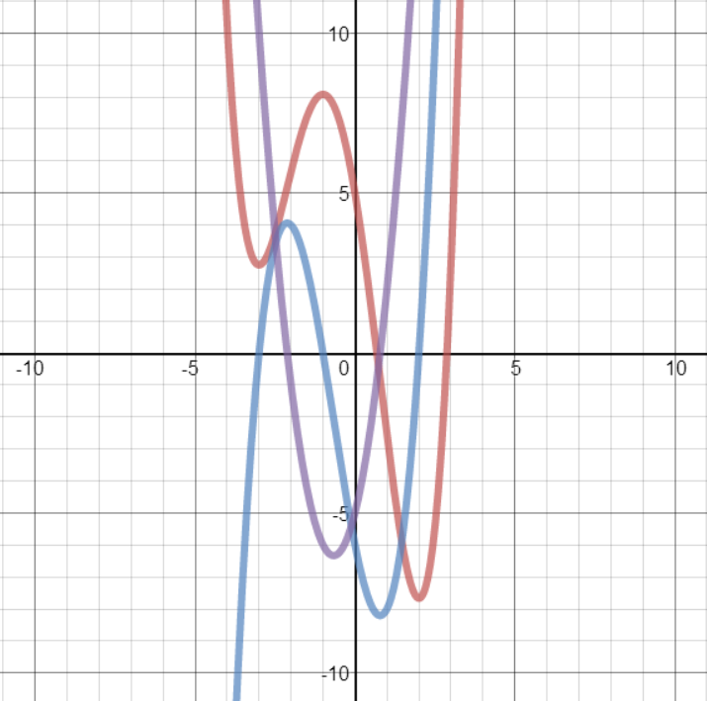I. A. 12.

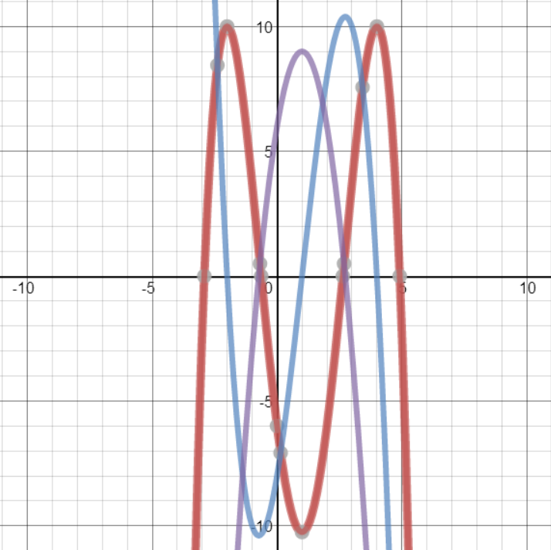I. B. 12.

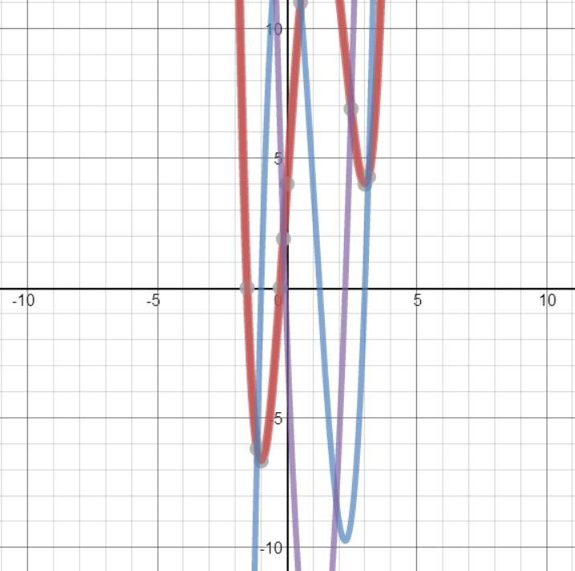I. C. 12.